Homework 1

Joey Martinez

Jackson Watkins

J Goocher

1.1

* Requirements Gathering
* High-level Design
* Low-Level Design
* Development
* Testing
* Deployment
* Maintenance
* Wrap-up
* Everything All At Once

1.2

* Requirements Gathering
  + Task centered around figuring out the necessary requirements for the project based on the users’ wants and needs.
* High-level Design
  + Higher level overview of the design of the project concerned with platform to use, data design to use, interfaces with other systems and covering every aspect of the requirements.
* Low-Level Design
  + Concerned with handling how each individual component specified in the high-level design will operate.
* Development
  + The task that is specific to the actual realization of the ideas previously stated, this is where the code is written.
* Testing
  + Task concerned with testing and removing bugs from the code written from the previous task.
* Deployment
  + The moment the project is given to the users, but also includes everything involved with rolling out the product, including training the users to use the product, new equipment for users, and any other unforeseeable problems to deal with.
* Maintenance
  + Once the software has been released, users will start to find bugs, and it is at this point that the programmers must go back and fix any issues that arise.
* Wrap-up
  + The point at which the project should be evaluated on its success and given a post-mortem.
* Everything All At Once
  + Not so much an individual task, but more of a collection of all these tasks, this subsection describes how time can be used efficiently to be able to finish as much as possible given what is finished at any given time.

2.5

* JBGE stands for “just barely good enough” and is a statement meant to describe how one should write documentation. The idea is that if documentation is too detailed and specific to what it is describing, it will be time wasted that could have been used for more important matters, and will have to be updated more frequently when code changes. This, however, should not be taken too seriously, as it is very easy to become too lazy with documentation.

3.2

* The total time is 32 days
* Start-G-D-E-M-Q-End

3.4

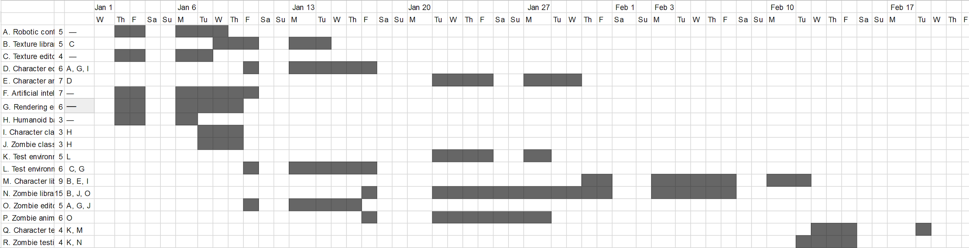

3.6

Exercise good risk management techniques. For each task determine the likelihood, severity, consequences, and workarounds (difficulty, impact, pros, cons)

This analysis can be used to study how different kinds of problems will affect the schedule.

3.8

The biggest mistake you can make is to ignore the problem and hope you can make up the time later.

The second biggest mistake you can make is to pile extra developers on the task and assume they can reduce the time needed to finish it.

4.1

Clear, Unambiguous, Consistent, Prioritized, Verifiable

4.3

1. Functional requirement
2. User requirement
3. User requirement
4. Functional requirement
5. Functional requirement
6. Functional requirement
7. Nonfunctional requirement
8. Nonfunctional requirement
9. Nonfunctional requirement
10. Functional requirement
11. Functional requirement
12. User requirement
13. Functional requirement
14. Functional requirement
15. Functional requirement
16. Functional requirement

Of all the requirements of the TimeShifter program, there are no requirements that would fall under the business requirement and implementation requirement categories.

4.9

Animate Mr. Bones

Custom soundtrack

Skin Pack (mature graphics)

Timer

Language packs (French, Vietnamese)

Difficulty settings (easy, medium, hard)

Leaderboard

Co-op

PvP

Fake Letters (create new symbols add them to keyboard)

Themed Word Packs (brands, places, etc)

Speech support for visually impaired

Android and iOS support (refactor Windows phone code)

**Must have**

Android and iOS support (refactor Windows phone code)

**Should have**

Difficulty settings (easy, medium, hard)

Leaderboard

Co-op

PvP

Speech support for visually impaired

**Could have**

Timer

Themed Word Packs (brands, places, etc)

Skin Pack (mature graphics)

Animate Mr. Bones

**Won't have**

Language packs (French, Vietnamese)

Fake Letters (create new symbols add them to keyboard)

Custom soundtrack